ASSIGNMENT – 3

S. Francin Samuel

20BCE2836

AES ANALYSIS

AES (Advanced Encryption Standard) is a widely used symmetric encryption algorithm that operates

on blocks of data. Here's an analysis of the AES algorithm, its key strengths and advantages, known

vulnerabilities or weaknesses, and real-world examples of its common usage:

1. Algorithm Overview:

- AES operates on blocks of data, where the block size is fixed at 128 bits (16 bytes).

- It supports key sizes of 128, 192, and 256 bits.

- AES consists of several rounds (10, 12, or 14 rounds depending on the key size) of substitution,

permutation, and mixing operations.

- It uses a combination of substitution, diffusion, and confusion techniques to achieve its security

properties.

- The same key is used for both encryption and decryption.

2. Key Strengths and Advantages:

- Security: AES is widely regarded as a secure encryption algorithm and is widely adopted by

governments, organizations, and industries worldwide.

- Efficiency: AES is efficient and performs well on a wide range of devices, including computers,

mobile devices, and embedded systems.

- Versatility: AES supports various key sizes, making it adaptable to different security requirements.

- Standardization: AES is a well-established standard, which ensures interoperability across different

systems and programming languages.

- Wide Support: AES is supported by numerous cryptographic libraries and frameworks, making it

easily accessible and usable in various applications.

3. Known Vulnerabilities or Weaknesses:

- Timing and Side-Channel Attacks: In certain scenarios, attackers can exploit timing differences or

side-channel information (such as power consumption or electromagnetic radiation) to infer

information about the encryption key.

- Key Management: AES itself does not handle key management. The security of the encryption

system relies on proper key generation, storage, and distribution mechanisms.

- Quantum Computers: AES is considered secure against classical computing attacks. However,

future advancements in quantum computing may weaken its security. Post-quantum encryption

algorithms are being developed as a potential replacement.

4. Real-World Examples:

- Secure Communication: AES is commonly used in secure communication protocols such as TLS

(Transport Layer Security) and VPNs (Virtual Private Networks) to encrypt data exchanged between

clients and servers.

- File and Disk Encryption: AES is utilized in various file and disk encryption software to secure

sensitive data stored on storage devices.

- Database Encryption: AES is employed for encrypting sensitive data stored in databases to protect

against unauthorized access.

- Wireless Security: AES is a component of the WPA2 (Wi-Fi Protected Access 2) protocol, which

ensures secure wireless communication.

RSA ANALYSIS

RSA (Rivest-Shamir-Adleman) is a widely used asymmetric encryption algorithm. Here's an analysis

of the RSA algorithm, its key strengths and advantages, known vulnerabilities or weaknesses, and realworld examples of its common usage:

1. Algorithm Overview:

- RSA is based on the mathematical difficulty of factoring large composite numbers into their prime

factors.

- It uses a public-private key pair, consisting of a public key for encryption and a private key for

decryption.

- The public key is derived from the product of two large prime numbers, while the private key

involves the prime factors of that product.

- RSA encryption involves raising the plaintext message to the power of the public exponent and then

taking the modulus of the result with the public key.

- RSA decryption involves raising the ciphertext to the power of the private exponent and taking the

modulus with the private key.

2. Key Strengths and Advantages:

- Security: RSA is based on the difficulty of factoring large numbers, which forms the foundation of

its security. The security strength depends on the key size.

- Asymmetric Encryption: RSA supports secure communication without requiring a shared secret key.

It enables confidentiality and authenticity of data exchanged between parties.

- Digital Signatures: RSA can be used for digital signatures, ensuring the integrity and authenticity of

digital documents.

- Key Exchange: RSA can facilitate secure key exchange in scenarios like establishing secure

communication channels or secure remote logins.

- Standardization: RSA is widely accepted and standardized, ensuring interoperability across different

systems and applications.

3. Known Vulnerabilities or Weaknesses:

- Key Size: The security of RSA relies on the size of the key. Smaller key sizes can be vulnerable to

attacks such as brute-force or factoring.

- Implementation Issues: Poor implementation of RSA or inadequate key generation methods can

introduce vulnerabilities, such as weak random number generation or side-channel attacks.

- Timing and Side-Channel Attacks: RSA implementations can be vulnerable to timing attacks or

side-channel attacks that exploit information leaked during the encryption or decryption process.

- Quantum Computers: RSA is vulnerable to attacks by quantum computers, which can efficiently

factor large numbers. Post-quantum encryption algorithms are being developed as alternatives.

4. Real-World Examples:

- Secure Communication: RSA is widely used in secure communication protocols such as SSL/TLS

to establish secure connections between clients and servers.

- Public Key Infrastructure (PKI): RSA is utilized in PKI systems for certificate-based authentication,

digital signatures, and secure email communication.

- Secure File Transfer: RSA is employed in secure file transfer protocols, like SFTP (Secure File

Transfer Protocol) and PGP (Pretty Good Privacy), for encryption and authentication.

- Secure Shell (SSH): RSA is used in SSH for secure remote logins, encrypted remote command

execution, and secure file transfers.

MD5 ANALYSIS

MD5 (Message Digest Algorithm 5) is a widely used cryptographic hash function. Here's an analysis of

the MD5 algorithm, its key strengths and advantages, known vulnerabilities or weaknesses, and realworld examples of its common usage:

1. Algorithm Overview:

- MD5 takes an input message of arbitrary length and produces a fixed-size 128-bit hash value.

- It applies a series of logical operations, including bitwise operations, modular arithmetic, and nonlinear functions, to process the input message.

- The resulting hash value is unique to the input message, meaning even a small change in the input

will produce a significantly different hash value.

2. Key Strengths and Advantages:

- Speed and Efficiency: MD5 is relatively fast and efficient, making it suitable for use in systems

where real-time hashing is required.

- Ease of Use: MD5 is easy to implement and use, requiring minimal computational resources.

- Checksum Validation: MD5 can be used to verify the integrity of files or data. By comparing the

calculated MD5 hash of a file with a previously generated hash, it can quickly determine if the file has

been altered.

3. Known Vulnerabilities or Weaknesses:

- Collision Vulnerabilities: MD5 is considered weak against collision attacks, where two different

inputs produce the same hash value. This weakness makes it unsuitable for cryptographic security

purposes.

- Security Weaknesses: The algorithm has been cryptographically broken, and numerous

vulnerabilities have been identified, including pre-image attacks and the ability to generate hash

collisions.

- Deprecated Usage: Due to its vulnerabilities, MD5 is no longer recommended for security-sensitive

applications or cryptographic purposes.

4. Real-World Examples:

- Data Integrity Checking: MD5 can be used to verify the integrity of downloaded files. The MD5

hash of the downloaded file is compared with the known hash value to ensure the file hasn't been

tampered with during transmission.

- Password Storage (Less Secure Usage): In some legacy systems, MD5 has been used to store

password hashes. However, this practice is no longer considered secure due to the vulnerability to preimage attacks and hash cracking techniques.

AES IMPLEMENTATION USING PYTHON

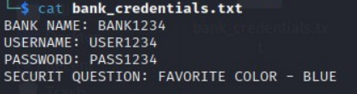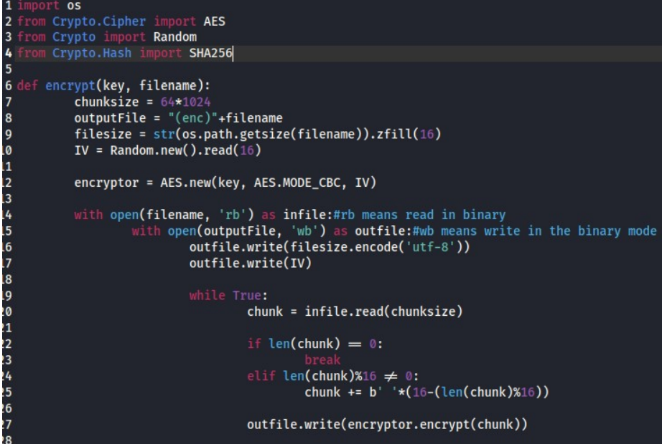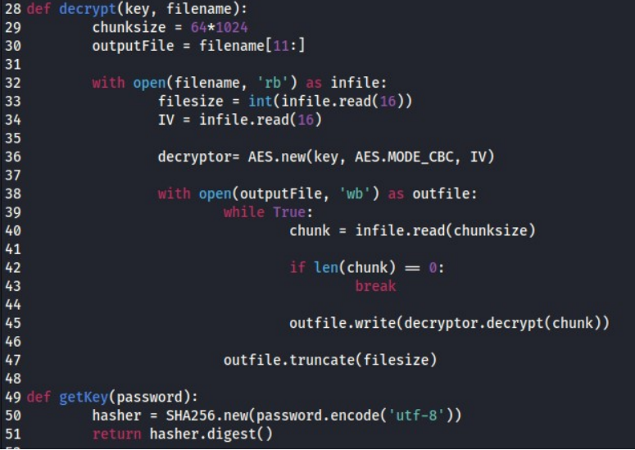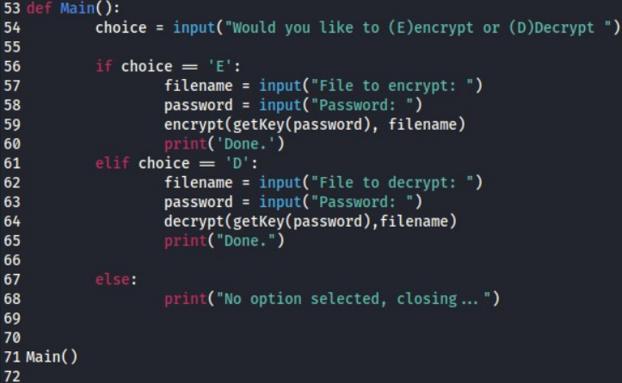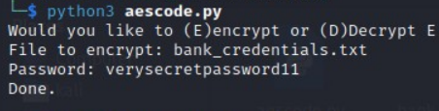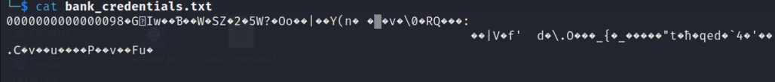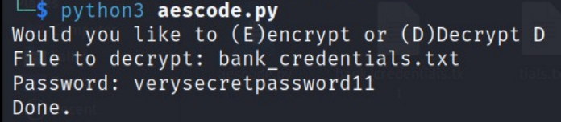

1. Potential Threats or Vulnerabilities:

a. Brute-Force Attacks: An attacker could attempt to guess the encryption key by systematically

trying all possible key combinations. Longer and more complex passwords can mitigate this threat.

b. Password-based Attacks: If the password used to generate the key is weak or easily guessable, it

can be vulnerable to dictionary attacks or password cracking techniques. Enforcing strong password

policies is essential.

c. Side-Channel Attacks: The implementation might be susceptible to side-channel attacks, such as

timing attacks or power analysis, which exploit information leaked during the encryption or decryption

process. Countermeasures like constant-time implementations or appropriate hardware protections can

mitigate these attacks.

2. Countermeasures and Best Practices:

a. Key Strength: Ensure the use of strong and unique passwords to generate the encryption key.

Implement password complexity requirements and encourage users to use password managers.

b. Key Management: Store encryption keys securely, such as using a key management system or

hardware security modules. Protect keys from unauthorized access and regularly rotate them.

c. Secure File Handling: Implement secure coding practices when handling files, such as validating

input, sanitizing file names, and avoiding path traversal vulnerabilities.

3. Limitations and Trade-offs:

a. Key Management: The implementation does not address the secure storage and distribution of

encryption keys. Proper key management practices should be implemented separately to ensure the

overall security of the system.

b. Algorithm Choice: The implementation uses AES with CBC mode, which is a secure choice.

However, other modes like GCM (Galois/Counter Mode) provide additional data integrity and

authentication features.

c. User Input Validation: The implementation assumes valid and trusted user inputs. Input validation

should be implemented to prevent attacks like path traversal, SQL injection, or buffer overflows.

Conclusion:

.